Journey From Data Warehouse to Data Lake

Dr. Geeta Rani, Puninder Kaur, Dr. Avinash Sharma

Chitkara University Institute of Engineering and Technology, Chitkara University, Punjab, India ^{1,2}, Department of Computer Science and Engineering, Maharishi Markandeshwar Engineering College, Mullana, India ³

Abstract: With the increase in high volume, velocity and variety of data, the traditional data analysis approaches are not adequate to handle diverse analysis challenges. Traditionally, data warehouse is being used which is integrated repository from various sources used for management decision making in business. Data is already in transformed and structured format stored in a costly reliable storage device. Data warehouse does not include all the data which may be supposed not required at the time of construction of data warehouse. With the advent of big data and in order to handle the data silos problem, the concept of Data Lake is introduced to handle the data analysis. Even data lakes have not replaced the data warehouse rather complement it. In this paper, firstly Data Lake is introduced and compared with predecessor technologies then various tools and techniques are discussed in order to implement Data Lake.
Keywords: Data Warehouse, Data Lake, data Analysis, Big Data, Hadoop.

INTRODUCTION
Data is a key to success of business and It keeps on snowballing day by day. Floods of data is produced from social platforms [1], IoT devices, digital devices and e-commerce etc. Organizations want to understand better about the customer choices to facilitate them with better service and earn maximum market share. It can be possible by customer data collected from various sources. In order to draw valuable inferences, data must be organized and analyzed in systematic manner.
Traditionally file system is used to handle the large pool of data. Then IBM introduced the concept of centralized Database Management System in 1966 and provides the three-level architecture to handle the problem of replication, accuracy, concurrency and recovery etc.
In 1980’s the Relational databases become more popular due to its simplicity and user friendly language i.e Structured Query Language (SQL).In 1990, there is major cultural and technological changes takes place in business world. Globalization and expansion of business in 2000 require exhaustive decision making to survive and excel. The conventional systems were good enough to handle the operational databases as data is stored as per the business processes but not sufficient for decision making.
So, in order to complement the operational database, an enterprise wide data warehouse [2] come into existence which is primarily equipped for decision making. Data warehouse [3] is stuffed with historical, non-volatile collection of data in pre-processed (summarized) form as per the subjects of interest. However, building data warehouse for every enterprise is not feasible. It is because that the data warehouse contains all the data of organization which is a costly affair. So, a mini warehouse or Data mart is being built that focus on selective department or subjects of interests.
With the advent of big data, cloud, IOT and social media there is rapid increase in volume of data. Every second, millions of data is produced in different formats which contain a huge value for business. This huge amount of data cannot be stored by the traditional techniques because it requires lot of preprocessing and even all data is not required every time. So, a new concept Data Lake is required which complement the earlier approaches and store all the data in raw format for future reference and only that data is processed which is required at that time. It is just like that we store lot of water in lakes for future reference in unprocessed form and only that much water is filtered that is required at home for drinking [4]. In section 2, concept of Data Lake has been introduced with its advantages. Data warehouse and Data Lake has distinguished in Section 3.Section 4 and 5 describes the Data Lake architecture and Hadoop Ecosystem. Challenges and recommendations are discussed in Section 5 and then Section 6 concludes the paper.
- DATA LAKE AND ITS BENEFITS
There is rapid increase in data with the development of internet, Cloud and web technologies. Thus, more sophisticated business Intelligence tools are required as they play a vital role in growth of any organization. Business Intelligence improves the business decision making by reveling the potential threats and opportunities [5, 6]. Initially the business Intelligence focus on organizational data only. Organizations build the data warehouse [7] which is integrated, subject-oriented, time-variant and non-volatile collection of data which is used explicitly for decision making. Data is stored already in processed (structured) form on a reliable media so that information can be extracted for decision making whenever required. But with the emergence of Big Data [7], it become a requirement to consider the broad view of data. It became a challenge to analyze the big data as it deals with volume, variety and varsity of data. It contains not only structured data but also semi-structured and unstructured data. There is a requirement to convert all variety of data to structured form to store into data warehouse. It is not practically feasible for organizations to increase the storage and processing capabilities in order to analyze the large volume of dynamic data. Moreover, other form data cannot be ignored as it contains the major part of important organization data (70%-80%). So, in order to handle current needs of business practical solution is Data Lake.
Data Lake is a lake (big repository) of data for an organization. Data is loaded from diverse [8-10} resources and stored in a cost-effective manner [11]. Data Lake can possess structured, unstructured, semi structured or binary data in raw form (as shown in fig.1) and processed when required for decision making. It can be said that Data Lake contains big data for an enterprise that is used for advanced data analytics.
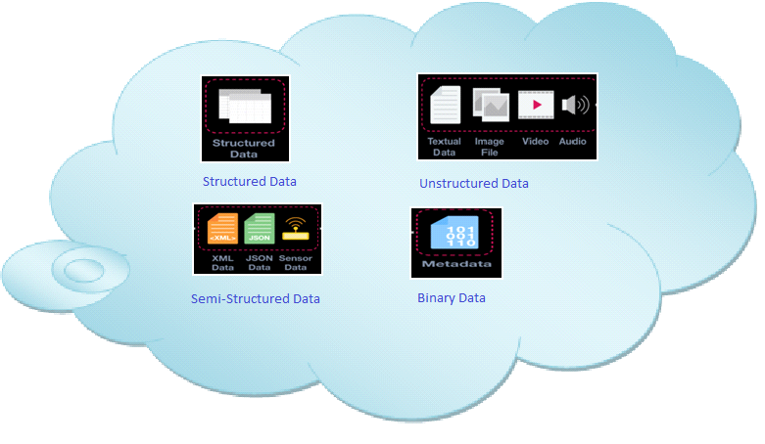
Figure 1: Types of Data in Data Lake

Data Lake [12] can be stored within the organization or on the cloud. But generally, companies like to store Data Lake on the cloud due to availability, scalability, cost and reliability. Cloud services are provided by number of vendors like Amazon, Google and Microsoft.
Key principals while building Data Lake [13] are
- Data is stored in a raw format. No preprocessing is required. Data is processed when it is required
- Data lakes are usually stored in inexpensive storage media.
- Data lakes follow Schema-on-read. So, no predefined schema is required.
- Data Lake does not replace Data warehouse rather complement it. Data lake is combination of big data as well as historical data of data warehouse.
- Data Lake is not Hadoop. It uses Hadoop for implementation of its subset of functions.
- Data Lake does not use single database rather number of relational, NoSQL and In-Memory databases are used to store variety of data.
- It uses HDFS for data storage which gives the flexibility of as much scalability as required
Benefits of Data Lake
Data lake give the unified view of organizational data instead of independent silos. It provides the platform for efficient storage, processing and analysis of data at low cost. It is because raw data is stored on commodity hardware. It provides flexibly to store unstructured and semi-structured data besides the structured data. So, there are number of benefits as shown in Fig.2
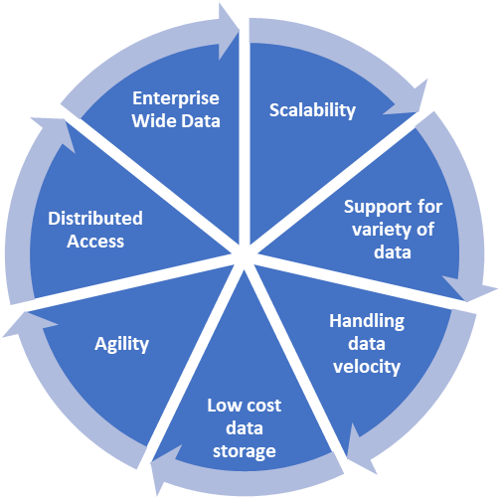
Figure 2: Benefits of Data Lake

- DATA LAKE VS DATA WAREHOUSE
Even Both Data Lake and Data Warehouse [13] are big data repositories used for business decision making still there is subtle difference between both. They differ in storage, Process, Schema, type of users, security and implementation as shown in table 1.
The first most common difference between data warehouse and Data Lake is flexibility. Data warehouse stores structured data whereas Data Lake stores the raw data. Data warehouse contains preprocessed historical data, well defined storage capacity and schema. It is stored in a costly reliable storage. Data warehouse is based upon the traditional ETL Process [4]. Firstly, data is extracted (E) from different sources, then it is transformed (T) into a preprocessed form. After that this preprocessed data is loaded into the data warehouse. Data warehouse need to have predefined schema so it follows “Schema-On-Write” approach.
On the other hand, Data Lake stores organization historical data as well as big data [14]. Data is stored in an in raw format on inexpensive storage device or on the cloud. The transformations are applied when it is required. In this way, complex transformation is removed in Data Lake from first stage. It follows ELT process instead of ETL in which data is firstly extracted, loaded and transformed only when it is required by the organization for data analysis. Data Lake is designed for heavy reads as well as heavy writes. It becomes possible because of metadata which is stored into Data Lake during extraction of database. So, it follows “Schema-On-Read” [15] approach.

Table 1: Data Warehouse vs. Data Lake Comparison
 | Data Warehouse | Data Lake
Type of Data | Historical data is stored in processed ​form | Historical data as well as Structured, Un-structured, Semi-structured and Binary Data is stored from Mobile phones, Social media, IOT devices etc.
Storage | Stored over the inexpensive storage media​ | Stored on high cost reliable storage ​
Process | ETL (Extract-Transform-Load) | ELT(Extract-Load-Transform)
Schema | Schema-On-Write | Schema-On-Read
User | Business Analysts | Business Analysts as well as Data Scientists
Security | Mature | Maturing
Technology | Sql Server ecosystem | Hadoop ecosystem etc.
Pros | Familiar User Interface | Flexible to store variety of data,  Low Cost,  Scalable,  Can store raw data for data Analysis
Cons | Rigid,  High Cost,  cannot store all the data required for data Analysis | Tools are required to organize and structure the data

- DATA LAKE ARCHITECTURE
Data lake architecture describes how data is actually stored and processed with in the Data Lake. Various Data Lake architectures [16,20] exists but the basic idea is same. Data Lake architecture has 5 Layers as shown in fig. 4.
- Data Ingestion Layer: This layer performs the first and most important task while building a data lake [21]. It is because the aim of Data Lake is to store all data of organization from different sources. It includes tools to transform data from internal as well as external data sources from SQL or NOSQL databases or data applications. It is flexible enough to support new data sources. Various tools are provided from different vendors ie. Apache, Google and Microsoft etc. Some of the most popular tools are Apache Thrift, Apache Avro, Apache Flume, Apache Nifi, Apache Kafka etc.
Data can be structured, unstructured or semi-structured in different formats. It has two sub-layers [22] to process real time as well as batch mode data. Real time processing layer ingest fast, quick and high priority data on the other hand batch layer ingest large amount of data for long running applications. Real time processing layer perform speedy reads and writes on the other hand batch processing layer performs serial read and write operations. So, Hadoop storage is good option for batch processing sub layer. However, it’s not suitable for real time processing sublayer
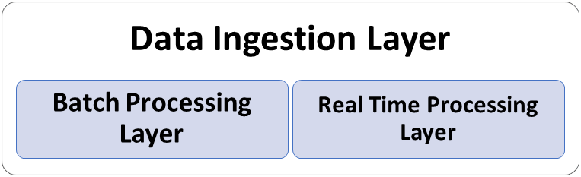
Figure 3:Data Ingestion Sub Layers

- Data Storage Layer: On this layer data is stored in raw form on low-cost data storage with its metadata [23]. Data is replicated up to a level in order to provide availability and reliability. Indexing, data compression and encryption techniques are applied for fast and secure access. It is scalable enough to support any volume of data.
Data Lake can store both the on-premise as well as cloud storage. HDFS [24-26] can be used for on-premise storage in which data is stored and replicated to different storage locations. On-premise data storage is preferred when more strict control is required for data security and privacy.
As different type of data is stored from various sources so the concept of Ployglot persistence is to leverage the power of different databases. On the other hand, for more scalable storage cloud storage is preferred. Various tools [27] used at this layer are Hadoop Distributed File System, GlusterFS, Amazon S3.
- Data Processing and Query Layer: This layer includes tools to process all kinds of data [12] .This includes batch processing system and real time processing system. This is the where actual analytics is performed by applying interactive queries by sql developers or analysts. Various tools [28] for processing and querying the Data Lake are Apache Sqoop, Apache storm, Apache Flink, Apache Spark, Map reduce, Azure Data bricks, Data lake solutions from AWS, Apache Spark, Apache redshift, Presto – SQL Query Engine For Big Data.
- Data Presentation and Visualization Layer: This is the one of the most important layers with which user interacts. Custom Dashboard, Tableau, Kibana, Intelligence Agents are used for this layer for data presentation and visualization [29].
- Data Management Layer: This layer works in association with all the layers. It involves maintaining the security, quality, value and reliability of data [30]. It also performs as resource scheduling, monitoring and governance [31-34].

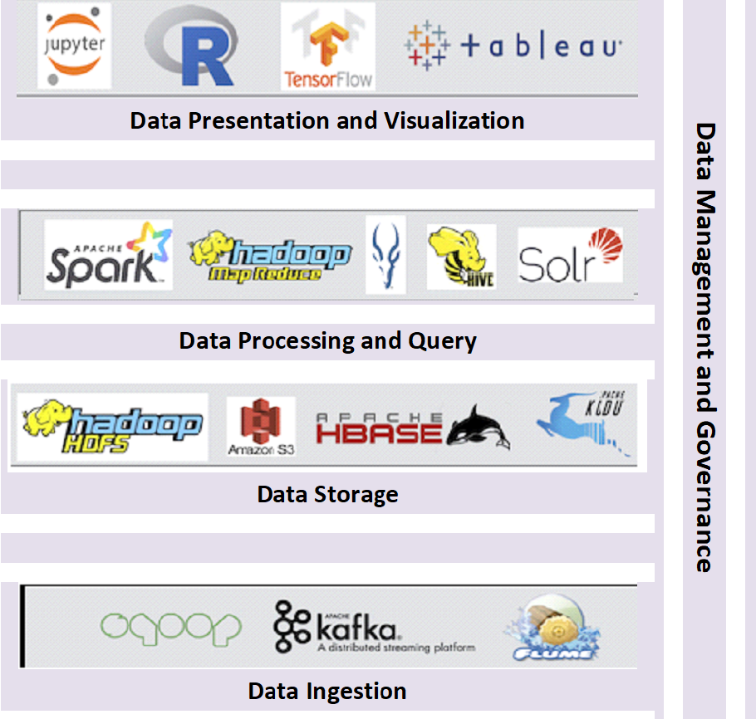
Figure 4: Data Lake Architecture

- DATA LAKE AND HADOOP
Hadoop is open-source framework used for big data management. It’s a good choice to implement data lake as effectively handles the storage, processing and analysis of data in Data Lake. Hadoop is written in Java and it is considered as one of the best projects of Apache. Hadoop solves the following problems of storing and processing Big data. Following are the driving features behind using Hadoop is
- Able to store of huge amount of data from variety of Sources
- Low-cost data storage as data is stored at commodity hardware
- Interoperability with other platforms
- Bigger tasks are divided in to smaller tasks and these are processed and analysed parallelly and later regrouped for final result.
Hadoop Ecosystem: Hadoop Ecosystem is a collection of tools that provides services like ingestion, storage, processing and analysis of big data. Various components of Hadoop are HDFS, YARN, MapReduce, Spark, Pig, Hive, HBase, Spark, Oozie, Flume, Sqoop, Mahout, Spark MLib, Kafka, Storm, Solr and Lucene.
- HDFS (Hadoop Distributed File System): This is core component of Hadoop Ecosystem which is used to store variety of data on distributed storage. Thus, it provides low cost storage with high scalability
HDFS has two types of component Nodes i.e NameNode and DataNode. NameNode act as a master node and maintains all the information regarding Data nodes and other blocks of HDFS. It keeps track regularly on Data nodes to check whether they are alive or not.
- YARN (Yet Another Resource Negotiator): This is another core component of Hadoop Ecosystem which is also called as brain of Hadoop Ecosystem as it manages all the processing activities. It also as resource allocator and scheduler.

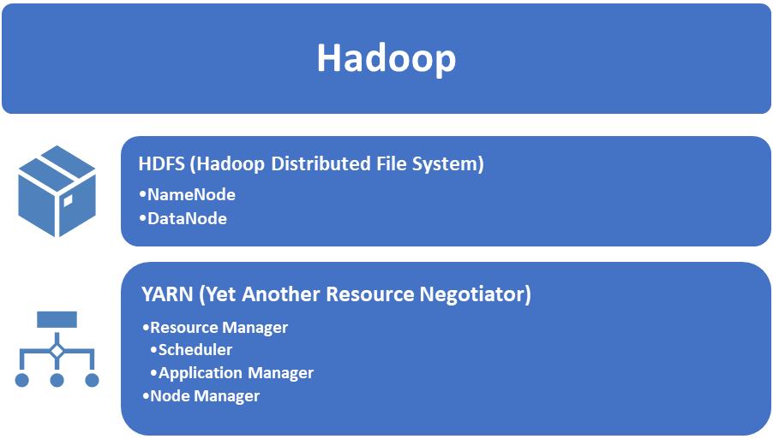
Figure 5: Hadoop Components

- MapReduce: MapReduce is a software framework in which is applications are created in different programming languages to process large data set. It is based on principle of Map (distribute) and reduce (aggregates).
- PIG: Pig was initially developed by Yahoo. It performs the extraction, transformation, processing and analysis of huge data. Pig has two components
  - Pig Latin which is scripting language like SQL.
  - The Pig Runtime which provides the execution environment for Pig Latin.
- HIVE: Hive is basically used for analysis of big data sets using HQL (Hive Query Language). HQL is a programming language for HIVE and supports all data types of SQL. It supports both batch processing as well as real time applications. HIVE has two components
  - Hive Command Line is used to execute Hive commands
  - JDBC/ODBC Driver provides the connection for data processing.
- Mahout: It provides environment for creating machine learning applications for analysis using clustering, filtering and classification.
- HBase: It is open source, NoSQL database which runs at the top of HDFS. It is written in Java.
- Zookeeper: It is a server which works at central level to provide co-ordination between different applications.
- Apache Flume: Flume is used to ingest unstructured as well as semi-structured data from RDBMS/ Datawarehouse to HDFS and vice-versa.
- Apache Sqoop: Sqoop is also data ingestion tool that is used to ingest not only unstructured and semi-structured data but also structured data.
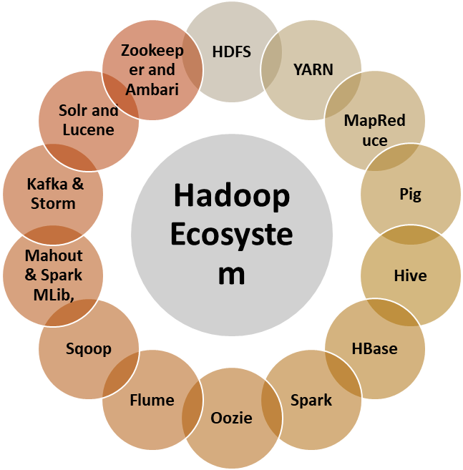
Figure 6: Hadoop Ecosystem

- DATA LAKE CHALLENGES AND RECOMMENDATIONS
Even the storage layer is changed in Data Lake still many of the challenges of data security, metadata management remain similar to data warehouse. More challenges are introduced into Data Lake due to its flexibility to store and access of data. Unlike data warehouse it fails to provide standard procedures for management, security, performance and access control of Data Lake. Major challenges are faced during building, managing and extracting the data lake.
Building of Data Lake
- As Data Lake contains huge volume of data, coming from variety of resources at a high speed. So, first challenge is faced while storing this huge volume of data. It cannot be stored in traditional databases. One possible solution is to use HDFS which is distributed file system where data is stored on commodity hardware and provides high throughput and scalability. However, HDFS is a distributed file system but not a database thus does not provide indexed structures and SQL based queries. Another solution to store Data Lake is to use NOSQL databases.
- As voluminous data is collected from diverse sources and stored in a raw form to build the data lake, it gives rise to lot of redundancies and inconsistencies. To address this challenge, meta data is added in the form of unique identifier [4] added to every element.
- Data lake follows the approach of early binding and late processing and it must be stored in such a way so that it can be available readily for processing and reporting when required. Moreover, required metadata must be added with data for bulk reads and writes. So, it must provide the flexibility to handle different types of sources, technologies to ingest verity of data.
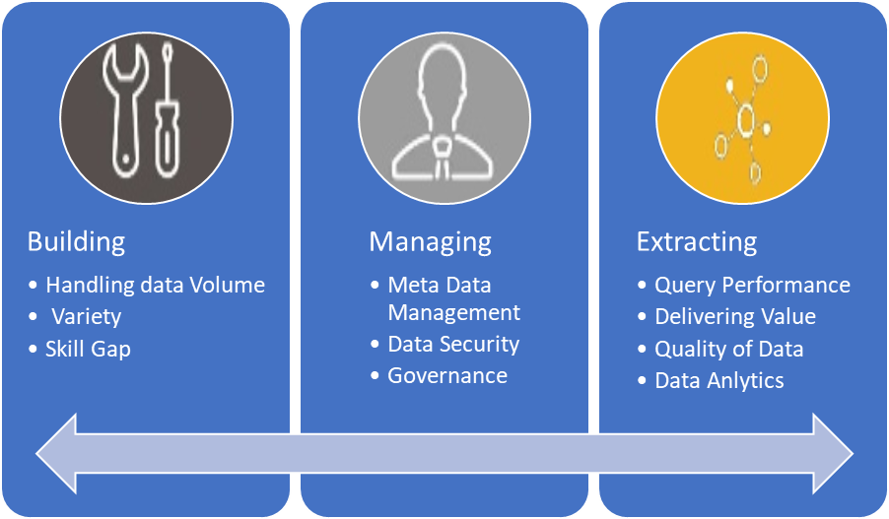
Figure 7: Challenges in Data Lake
Managing of Data Lake
- Data in Data Lake need to be stored in original form and transformed later when it is required. It is because data mining and analytics tools work well in detailed and original data. Till now there are no sophisticated procedures to escape Data Lake from wrong data, incomplete data and duplicated data. In order to access the data later, effective metadata management is required. Metadata need to be stored with business grocery and user semantics so that data lake user can find the appropriate data in an efficient manner.
- Another challenge is faced while managing the data. If not properly managed, it may lead to data Swamp. In order to address this issue date must be stored in controlled manner. Policy based governance is required to answer the questions like who, when and how to load the data. Moreover, data anti-dumping policies need to be built to secure the useful data.
- Another major challenge of Data Lake is to break down the problem of data silos. Data Lake must have unified view of data instead of independent pockets.
- It must also provide the secure access to users so that right data can be accessed by right people. As it deals with semantically inconstant data and most of the tools and technologies are open sourced so it may compromise the security of data. So normally different encryption and decryption techniques are applied in order ensure the security [2] of data.
Extracting the valuable Data
- Major intends of Data Lake is to get the value out of it so that right business decisions can be made. Data Lake must work in integration with machine learning and business analytics tools.
- Even when the data is entered into the Data Lake unique identifiers are attached to every element and metadata for the same is stored. But getting the value out of Data Lake repository remain a challenge as the constantly data extraction has to start from fresh due to lack of standard procedures thus compromise performance [1].
- Moreover, there is no standard mechanism for advanced searching. This is happening due to Data Lake inherent characteristic of storing all kind of data without focusing how to extract quality data.
CONCLUSION
Data warehouse is made to answers predefined set of queries on the other hand Data Lake is built to provide new insights from data. Data Lake is the union of Big Data with data analytics to get the business value. The bright side of Data Lake is that it provides flexible, scalable and cost-effective way to manage different types of data even it requires the certain skill set and management support to implement it. Data Lake does not replace the data warehouse or RDBMS. It just complements them. Actually, it depends on business to business or project to project to implement Data Lake. Even if some organization plan to implement it, it should not be implemented gradually to avail the full advantage. In future both data warehouse and Data Lake can be integrated to utilize the strength of both technologies.

REFERENCES
- Abourezq M, Idrissi A. Database-as-a-service for big data: An overview. International Journal of Advanced Computer Science and Applications. 2016;7(1).
- Khine PP, Wang ZS. Data lake: a new ideology in big data era. InITM web of conferences 2018 (Vol. 17, p. 03025). EDP Sciences.
- Campbell C. Top five differences between data lakes and data warehouses. White paper: BLUE GRANITE. 2015 Jan.
- Fang H. Managing data lakes in big data era: What's a data lake and why has it became popular in data management ecosystem. In2015 IEEE International Conference on Cyber Technology in Automation, Control, and Intelligent Systems (CYBER) 2015 Jun 8 (pp. 820-824). IEEE.
- Kowalczyk M, Buxmann P. Big data and information processing in organizational decision processes. Business & Information Systems Engineering. 2014 Oct;6(5):267-78.
- Xia BS, Gong P. Review of business intelligence through data analysis. Benchmarking: An International Journal. 2014 Apr 1.
- Stonebraker M, Çetintemel U. " One size fits all" an idea whose time has come and gone. InMaking Databases Work: the Pragmatic Wisdom of Michael Stonebraker 2018 Dec 1 (pp. 441-462).
- Madera C, Laurent A. The next information architecture evolution: the data lake wave. InProceedings of the 8th international conference on management of digital ecosystems 2016 Nov 1 (pp. 174-180).
- Fang H. Managing data lakes in big data era: What's a data lake and why has it became popular in data management ecosystem. In2015 IEEE International Conference on Cyber Technology in Automation, Control, and Intelligent Systems (CYBER) 2015 Jun 8 (pp. 820-824). IEEE.
- O'Leary DE. Embedding AI and crowdsourcing in the big data lake. IEEE Intelligent Systems. 2014 Nov 7;29(5):70-3.
- Tyagi P, Demirkan H. Data lakes: the biggest big data challenges. Analytics Magazine. 2016:56.
- Ravat F, Zhao Y. Data lakes: Trends and perspectives. International Conference on Database and Expert Systems Applications 2019 Aug 26 (pp. 304-313). Springer, Cham.
- Pasupuleti P, Purra BS. Data lake development with big data. Packt Publishing Ltd; 2015 Nov 26.
- Walker C, Alrehamy H. Personal data lake with data gravity pull. In2015 IEEE Fifth International Conference on Big Data and Cloud Computing 2015 Aug 26 (pp. 160-167). IEEE.
- Hai R, Geisler S, Quix C. Constance: An intelligent data lake system. InProceedings of the 2016 international conference on management of data 2016 Jun 26 (pp. 2097-2100).
- Madsen M. How to Build an enterprise data lake: important considerations before jumping in. Third Nature Inc. 2015:13-7.
- Giebler C, Gröger C, Hoos E, Schwarz H, Mitschang B. Leveraging the data lake: Current state and challenges. InInternational Conference on Big Data Analytics and Knowledge Discovery 2019 Aug 26 (pp. 179-188). Springer, Cham.
- Gorelik A. The enterprise big data lake: Delivering the promise of big data and data science. O'Reilly Media; 2019 Feb 21.
- Sharma B. Architecting data lakes: data management architectures for advanced business use cases. O'Reilly Media; 2018.
- Zikopoulos P. Big data beyond the hype: A guide to conversations for today's data center. McGraw-Hill Education; 2015.
- Stein B, Morrison A. The enterprise data lake: Better integration and deeper analytics. PwC Technology Forecast: Rethinking integration. 2014;1(1-9):18.
- John T, Misra P. Data Lake for enterprises. Packt Publishing Ltd; 2017 May 31.
- Mohamed A, Najafabadi MK, Wah YB, Zaman EA, Maskat R. The state of the art and taxonomy of big data analytics: view from new big data framework. Artificial Intelligence Review. 2020 Feb;53(2):989-1037.
- Giebler C, Gröger C, Hoos E, Schwarz H, Mitschang B. Leveraging the data lake: Current state and challenges. InInternational Conference on Big Data Analytics and Knowledge Discovery 2019 Aug 26 (pp. 179-188). Springer, Cham.
- Dixon J. Data lakes revisited. James Dixon’s Blog. 2014 Sep.
- Madera C, Laurent A. The next information architecture evolution: the data lake wave. InProceedings of the 8th international conference on management of digital ecosystems 2016 Nov 1 (pp. 174-180).
- Mathis C. Data lakes. Datenbank-Spektrum. 2017 Nov;17(3):289-93.
- Rungta, K. (2020, August 25). What is Data Lake? It’s Architecture. https://www.guru99.com/data-lake-architecture.html
- Dhanotia Pranjal (2020,April6)https://www.yash.com/blog/data-lake-architectural-components/.https://www.yash.com/blog/data-lake-architectural-components/
- Mathis, C. (2017). Data lakes. Datenbank-Spektrum, 17(3), 289-293.
- Fang, H.: Managing data lakes in big data era: What’s a data lake and why has it became popular in data management ecosystem. In: Proceedings of the 2015 IEEE International Conference on Cyber Technology in Automation, Control, and Intelligent Systems (CYBER) (2015).
- IBM Analytics: The governed data lake approach. IBM. (2016).
- Gartner Inc.: Gartner Says Beware of the Data Lake Fallacy, https://www.gartner.com/newsroom/id/2809117, (2014).
- Patel, P., Wood, G., Diaz, A.: Data Lake Governance Best Practices. DZone Guide to Big Data - Data Science & Advanced Analytics 4, 6–7 (2017).
- Ayman Alserafi, Alberto Abell´o, Oscar Romero, Toon Calders,Towards Information Profiling: Data Lake Content: Metadata Management, 2016 IEEE 16th International Conference on Data Mining Workshops.
- Brian Stein, Alan Morrison,” The enterprise data lake: Better integration and deeper analytics, Technology Forecast: Rethinking integration”, Issue 1, 2014, Retrieved 25, Aug. 2017: www.pwc.com/us/en/technology-forecast/2014/cloudcomputing/assets/pdf/pwc-technology-forecast-data-lakes.pdf. [
- Chris Campbell, Top five difference between data lakes and data warehouses, JAN 26, 2015, Blue Granite, Retrieved Aug 25, 2017. https://www.bluegranite.com/blog/bid/402596/top-five-differences-between-data-lakes-and-datawarehouses.
- Chuck Yarbrough, 5 Keys creating killer data lake, Retrieved July 21, 2017. http://www.pentaho.com/blog/5-keys-creating-killer-data-lake.

